# **Drowning? Pt. 2**

**Zoe's avatar**

[Zoe](https://substack.com/@zoeffc)

Jul 26, 2024

Share

Hi there!

I am between calling this week’s note either “Glimmers” or “Drowning? Pt. 2”. I suppose that by the point you are reading this, that decision has been made.

**Glimmer:** /ˈɡlɪm.ɚ/ a moment in your day that brings a little bit of joy to you, particularly when your daily experience is a little more gloomy.

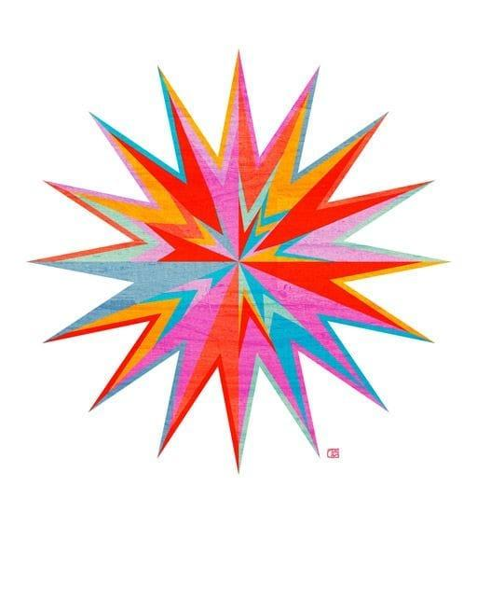

First some housekeeping:

📫 If a friend forwarded you this newsletter (then you have some really cool friends), and you may want to consider joining us [*here*](https://femme-futures.beehiiv.com/subscribe) for regular updates.

[Subscribe](https://femme-futures.beehiiv.com/subscribe)

🧲 Got some thoughts you want to share? Join us on [*Discord*](https://discord.gg/592wuyvx?utm_source=femme-futures.beehiiv.com&utm_medium=referral&utm_campaign=drowning-pt-2) to chat all things newsletter and corporate life.

[Discord](https://discord.gg/N84WxemQ?utm_source=femme-futures.beehiiv.com&utm_medium=referral&utm_campaign=drowning-pt-2)

As you well know, the post-college transition has been tumultuous for me. I mean, that is why the Femme Futures Cooperative exists. It is also why I have a lot of tools that I keep in my back pocket for navigating any number of challenging situations. One such tool has been “glimmers”.

I explained glimmers to one of my best friends when she was 11 months into a job hunt and feeling pretty hopeless. That is a large scale hopeless that can be really daunting to try to address. While I am a major proponent of therapy and relying on your support systems to get you through times like that, sometimes that feels out of reach. That is where a glimmer comes in.

My glimmers have included, seeing new leaves on my plants, watching my dog get super excited to see me, and going out for dinner with new friends. They are little shocks that get my system to see that there is joy and growth in my life.

This week, glimmers included:

* nailing a bouldering route that I had been working at for weeks
* dog-sitting for TWO of the most fabulous, sweet and playful pups
* having conversations with friends and mentors that reminded me what I am working towards on a regular basis.

The advice to keep a gratitude journal sounds trite at this point. I do list Three Good Things at the top of every one of my journal entries, because the psychologists are really onto something there.) Often times, the act of writing gratitudes can result in the feeling of guilt for having something that so many other people do not have. Everyone has something that someone else wants, that guilt is inevitable, and I truly admire you for reflecting on it. However, it is not going to pull us out of the gray as we may need it to. Try identifying your glimmers instead. I am sure that at some point, I will write a whole post about journaling and its magical potential, so I will refrain from going into that here. Though, a good practice for a dark time is having a daily routine of writing down three glimmers.

In addition to journaling, you can train your brain to identify glimmers as they happen. Point them out to yourself in your everyday life. Notice when little things make you smile. An influencer who I follow has a “thank you, more please” challenge where she suggests that when you see things that you like in the world, you verbally address it by saying “thank you, more please!” (her book will be linked in the resources below!). This practice gets you to pause and soak in that good thing, and opens up your brain to noticing more of them.

I thought that I had come up with this all on my own, but I have never once had an original thought in this, the Age of the Internet. So if you want more resources on glimmers, I will link some below. I’d be curious what you find!

Wishing you all the best,

Zoe

P.S. I am 100% serious when I say that I want a glimmer tattoo. I will not be taking questions or suggestions on this.

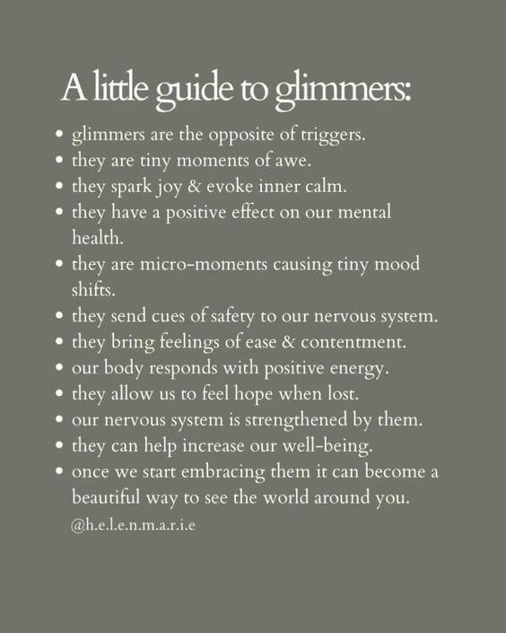

📌**Resources**

* [*Thank You, More Please!*](https://www.datebrazen.com/book?utm_source=femme-futures.beehiiv.com&utm_medium=referral&utm_campaign=drowning-pt-2) The book and influencer primarily focus on strategies for navigating modern dating (eek…) but she does a fantastic job of providing real world examples of glimmers.
* More psychology heavy explanation of glimmers [*here*](https://www.verywellmind.com/what-is-a-glimmer-5323168?utm_source=femme-futures.beehiiv.com&utm_medium=referral&utm_campaign=drowning-pt-2)
* A video explanation [*here*](https://www.youtube.com/watch?v=84eBa4AhwFU&ab_channel=MindKnown&utm_source=femme-futures.beehiiv.com&utm_medium=referral&utm_campaign=drowning-pt-2)

**Femme Futures Cooperative Founding Principles**

💚**Mission**: The mission of Femme Futures is to create a community space for young professionals who identify as over-achievers and activists to generate collective success by providing resources and platforms to thrive in challenging workplace environments.

💙**Vision**: To contribute to a world where driven individuals are equipped with the tools, guidance, and connections to overcome systemic barriers, fully utilize their talents, and enact positive change in their organizations and communities.